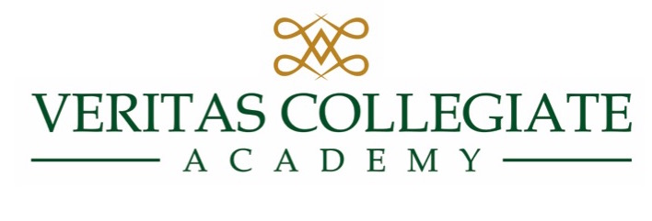

Transcript and Records Request

Student ________________________________________________________________

Address ________________________________________________________________

Telephone ______________________________________________________________

Birth date _______________________________________________________________

Current School:

School _________________________________________________________________

Address ________________________________________________________________

Telephone ______________________________________________________________

School Admissions email address ____________________________________________

I authorize the release of an official transcript, current grades, standardized test results, attendance records, immunization form, health records, Birth Certificate, psychological / educational evaluation, and any special education records to be sent to:

Veritas Collegiate Academy
1832 Elbow Road,
Chesapeake, VA 23320
Bonnie Ostrander, Admissions Director
bostrander@veritasca.com
Phone (757) 410-5095

____________________________________________________________ _________________________
Parent / Guardian Signature Date

